Name : Ali Hussien Ahmed
Partners : None.
Section : 2

Emails: Fci04-041@fci.aun.edu.eg
Alihussin.it@gmail.com

Project Name:
Life Video&Audio Conferencing Tool

Description:
A socket based application that is used to transmit life video and audio-which can also called Voice over IP between two computers connected together via LAN.
Project initially will be developed to run only between two hosts, a Client and Server, both must own the capturing devices the Webcam and Microphone.
Application can be extended to be a Server (fig 1) exchanging data-Voice&Video-with several Clients that is known as broadcasting, in such application a multithreaded Server is required to process clients’ requests.
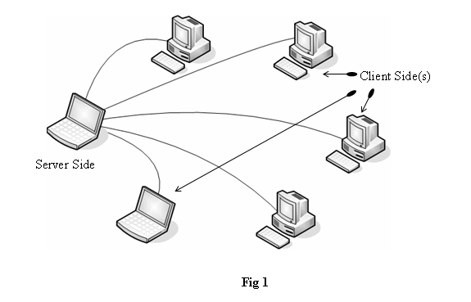
Details:
Application can be divided into six steps
- Capturing Data.
That is what we concern in our course, how to capture frames from the camera, how to display it in the local computer view, but it’s quit different as audio data are continuous the decision of where to “cut” is quit difficult but I’ll got it by “try and error” .

- Compressing Data.
Needed to save network bandwidth and reduce traffic, but unfortunately this step will be skipped as we don’t know image compression techniques that is used to compress video frames.

- Sending Data.
This is the easiest process because standards will help me, as known video and audio data is transmitted over UDP/IP Protocols, because of the fast transmission speed, free of redundant control bits (TCP) and lost tolerance.
- Receiving Data.
Raw bytes are received and processed and next to...

- Decompression.
If a compression technique was used.

- Presentation.
In case of sound bytes to the sound card directly (waveOutOpen…).
In case of video bytes → frame by frame displayed in a picture box

Expected Application:
Before beginning to code application I prefer to Design GUI (fig 2, 3, 4) it’s not a final design but it is just the first step.

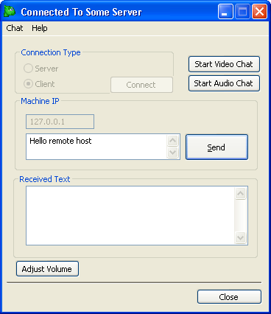
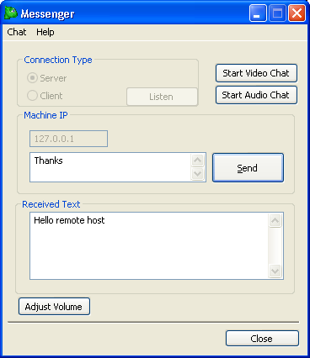

Fig 2 – Connected Client Side. Fig 3 – Connected Server Side.

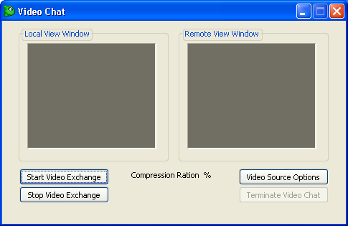

Fig 4 – Video exchange dialog.

Expected Troubleshooting:
- How to capture video and online send it to remote host?
- Whether to use MCI device interfaces or the ready device DLLs?
- Synchronization matters …
- What about compression?
- Capturing life video.
- ….

Tool:
Till now I haven’t decided whether to use C#.Net or Visual C++ (MFC Application) or even to search for a ready one and create the full discussion and presentation.

Recommendations:
أرجو الموافقه على المشروع وارسال الرد فى وقت قريب

Signature:
Ali Hussien Ahmed.
IT Department.

THANK YOU for Reading

